B.Sc. Hons. in Software Engineering
CW228
Project Plan

Project Title: Number Plate f
Recognition f

Supervisor: Nigel Whyte __f

Student ID: C00131013 f

Student Name: Ronghua Ou f

Date: December 5, 2010 f

Introduction
This document is to make a plan for the whole project, including the tasks in each develop phases and the duration of each task.

Project Plan

Gantt chart Of Project Plan
The whole project is scheduled by each task. Each task is given a certain duration to deal with. Details are listed in a Gantt chart made with Microsoft project.

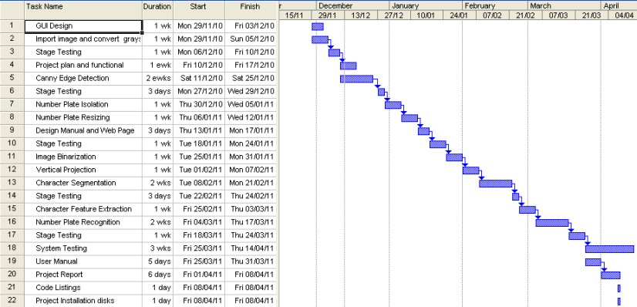

Task Details
Task ID | Task Name | Task Details
1 | GUI Design | Design of user interface
2 | Import original image and convert to grayscale | Import image, display it in the Original Image Panel. Implement grayscale convention.
3 | Stage Testing | Test all implemented functions
4 | Project Plan and Functional | Project Plan and Functional Specification Document
5 | Canny Edge Detection | Implement Gaussian smoothing algorithm, edge thresholding algorithm and present the edge detected image.
6 | Stage Testing | Test all the implemented functions in edge detection and previous functions.
7 | Number Plate Isolation | Search the number plate area by using a slide-window move around in the edge detected image.
8 | Number Plate Resizing | Remove the border of the number plate
9 | Design Manual and Web Page | Design Manual Document and Web Page Introdution
10 | Stage Testing | Test all the implemented algorithm in number plate localization and previous functions.
11 | Image Binarization | Convert the isolated number plate sub-image into black and white.
12 | Vertical Projection | Apply vertical projection onto the binary sub-image.
13 | Character Segmentation | Separate the character in the binary sub-image by using the vertical projection data.
14 | Stage Testing | Test all the implemented functions in segmentation and previous functions.
15 | Character Feature Extraction | Extract the features from each character by using character feature extraction algorithm, store the feature into a character feature array.
16 | Number plate recognition | Compare the character feature array with the templates to recognize number plate.
17 | Stage Testing | Test all the implemented functions in character recognition part.
18 | System Testing | Test the entire system.
19 | User Manual | User Manual Document
20 | Project Report | Project Report Document
21 | Code Listings | Code Listings Document
22 | Project Installation Disks | Make a Installation Disks for the system

